**Bug Report**

Jaehoon Lee 11545296

## Bug Report:

**Bug 1: Game does not pay out at correct level.**

**When player wins on 1 match, balance does not increase.**

## Before Fixing Bug 1

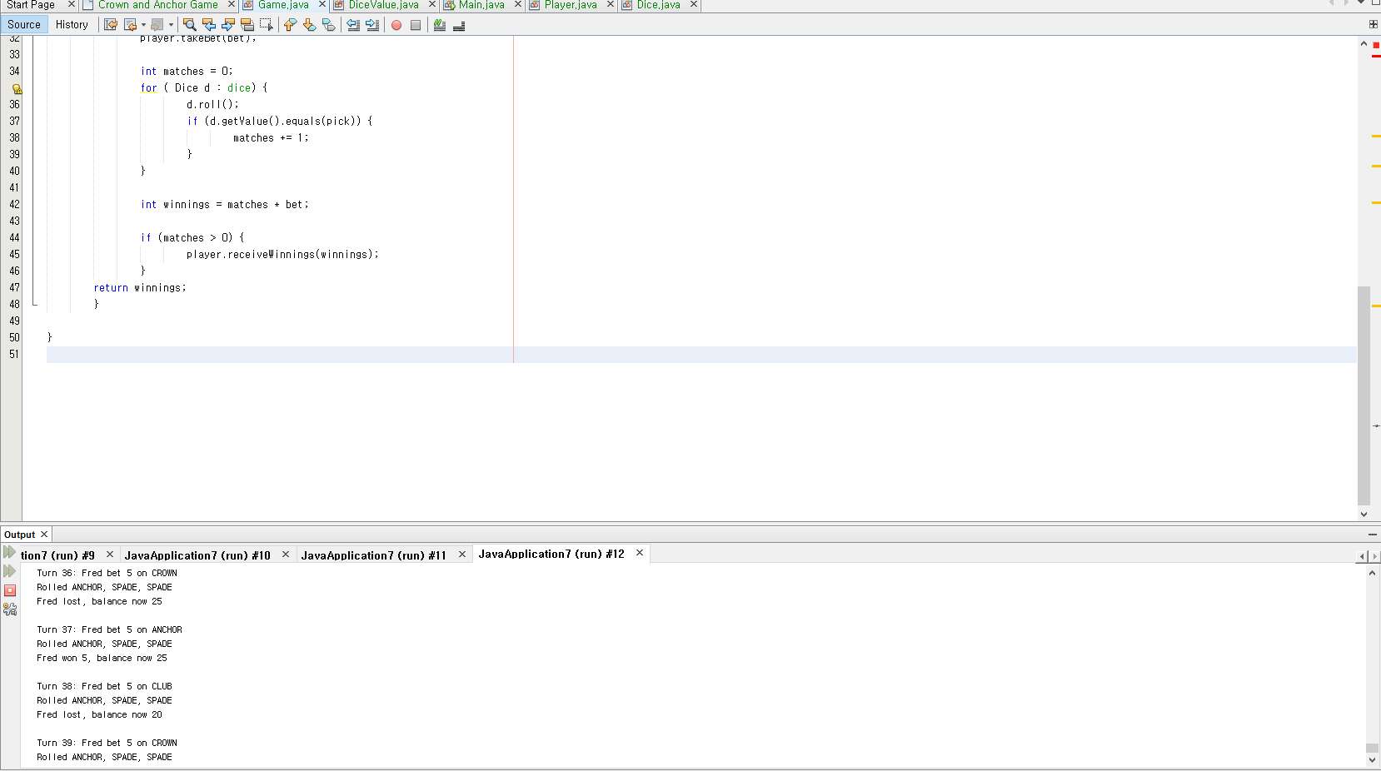

**From here As you can see the points won’t increase even the players wins the game.**

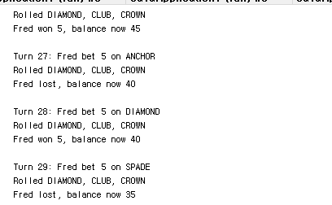

## After fixing bug 1 by adding

## + Bet in line 45

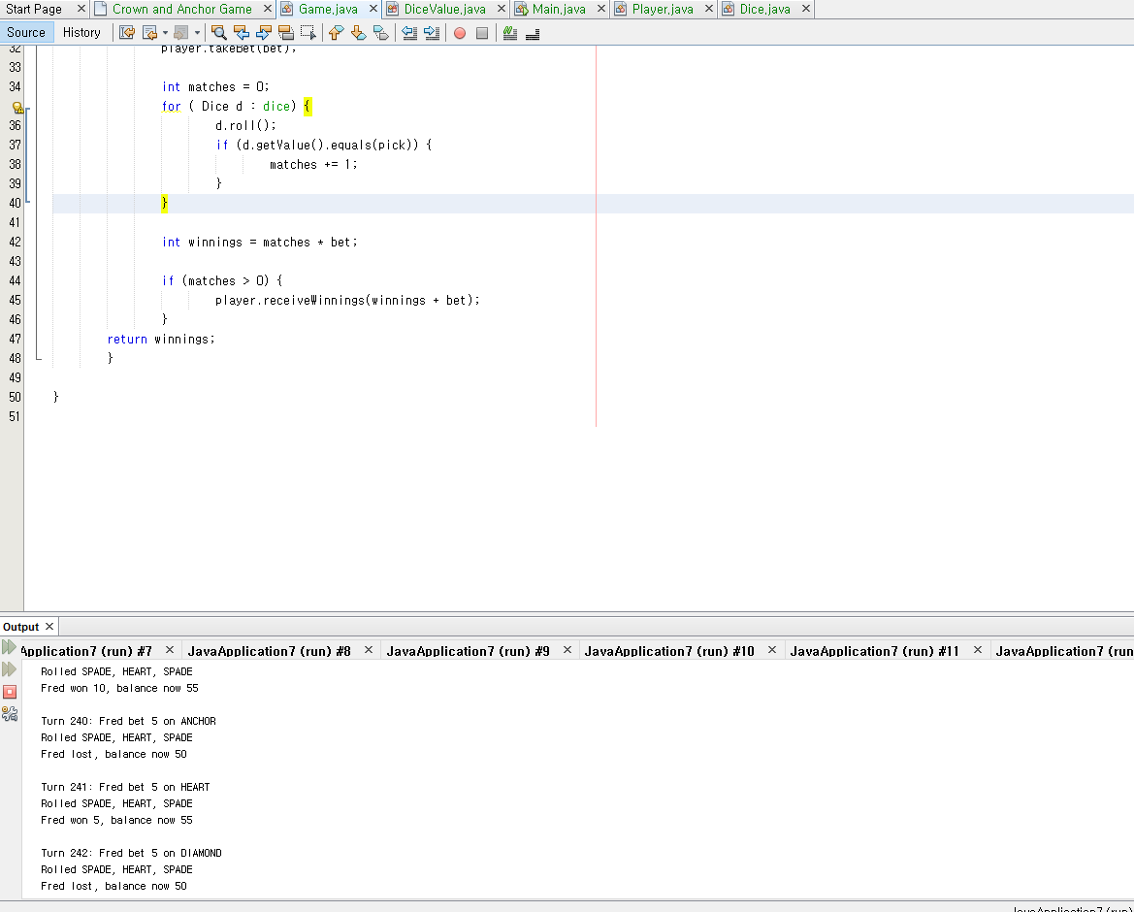

As you can see point increases after player wins.

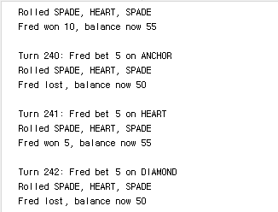

**Bug 2:** Player cannot reach betting limit:

Limit set to 0, but game ends with player still with 5 (dollars) remaining.

**Bug 3:** Odds in the game do not appear to be correct.

Crown and Anchor games have an approximate 8% bias to the house. So he wins: (win+lose) ratio should approximately equal 0.42. This does not appear to be the case.